spaceship rpg gAME

Text Based Game

CIS_350 Winter 2024

Professor: Dr Nandigam

Team members

Adrian F Perez-Lopez

Eric Moras

Phuc Le

Contents

Project Information 3

Features 3

Screenshots 3

Project Plan 6

Requirements & Definition 6

Development 6

Verification 6

Maintenance 6

Umbrella Activities 6

Requirements & Specification 7

Use-Cases Diagram 7

Use-Cases Diagram Description 8

Natural Language Requirements 11

Traceability Matrix 11

Design 12

Code Standards 13

Static Analysis 13

Code Documentation 20

Configuration Management 23

Verification 24

Unit Tests 24

Code Coverage 24

Requirements Coverage 28

Postmortem 29

Earned Value 29

Variances 29

Lessons Learned 29

Work Cited 30

# Project Information

The Role-Playing Game (RPG) project is a text-based game that will be a single character (space janitor). The janitor(character) faces different challenges while cleaning shipwrecks; therefore, he acquires different fighting techniques to help him move up in rank, such as cadet and captain, and ultimately becomes a king.

As the character moves through different maps, enemies will get stronger; thus, the player will be rewarded at the end of each challenge. These rewards will help him increase his stats by acquiring various combat tools.

## Features

* Username Input.
  + The user interface will get player’s name; otherwise, Bob will be assigned if user does not want to provide a name.
* Stats.
  + This feature will display how the points are going to be distributed while playing; in addition, the player will be awarded 5 free points to get the game going.
* Game Screen.
  + A map will be displayed showing the player current position.
  + Stat information to keep track of the game.
  + Message screen showing the interaction of the player.

## Screenshots

* 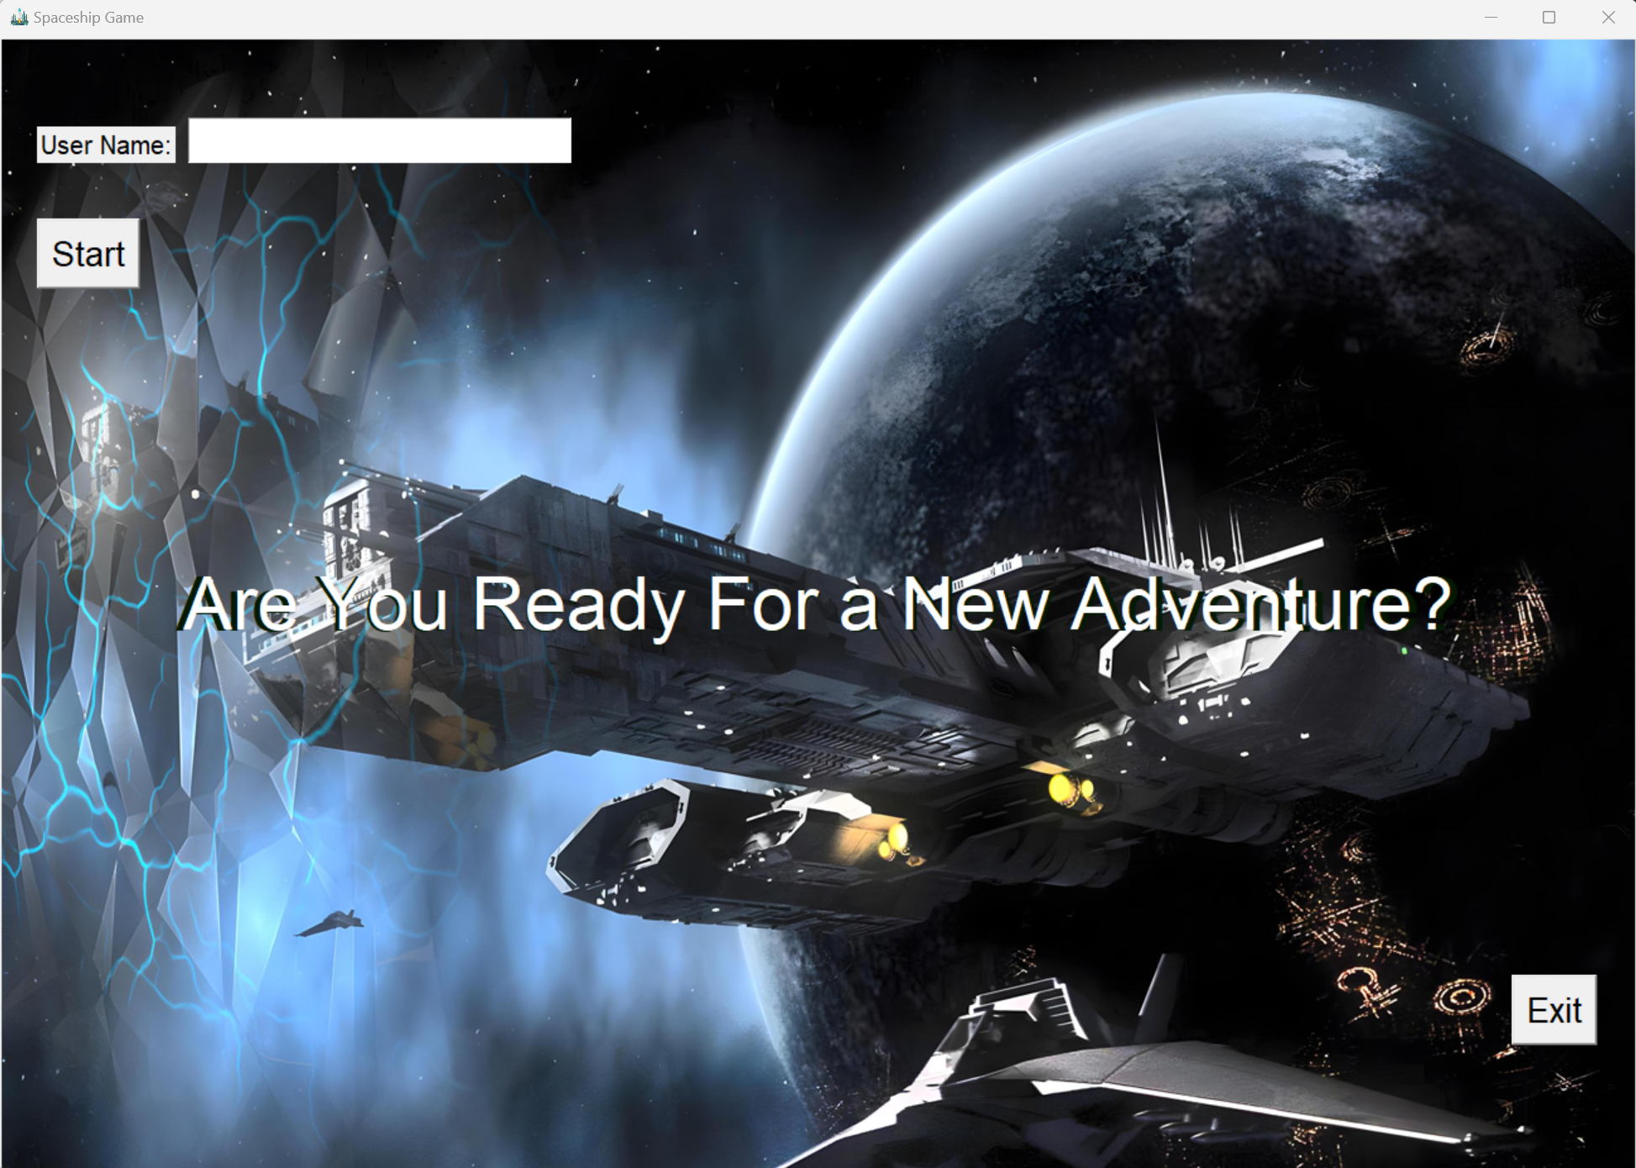Name input.
* 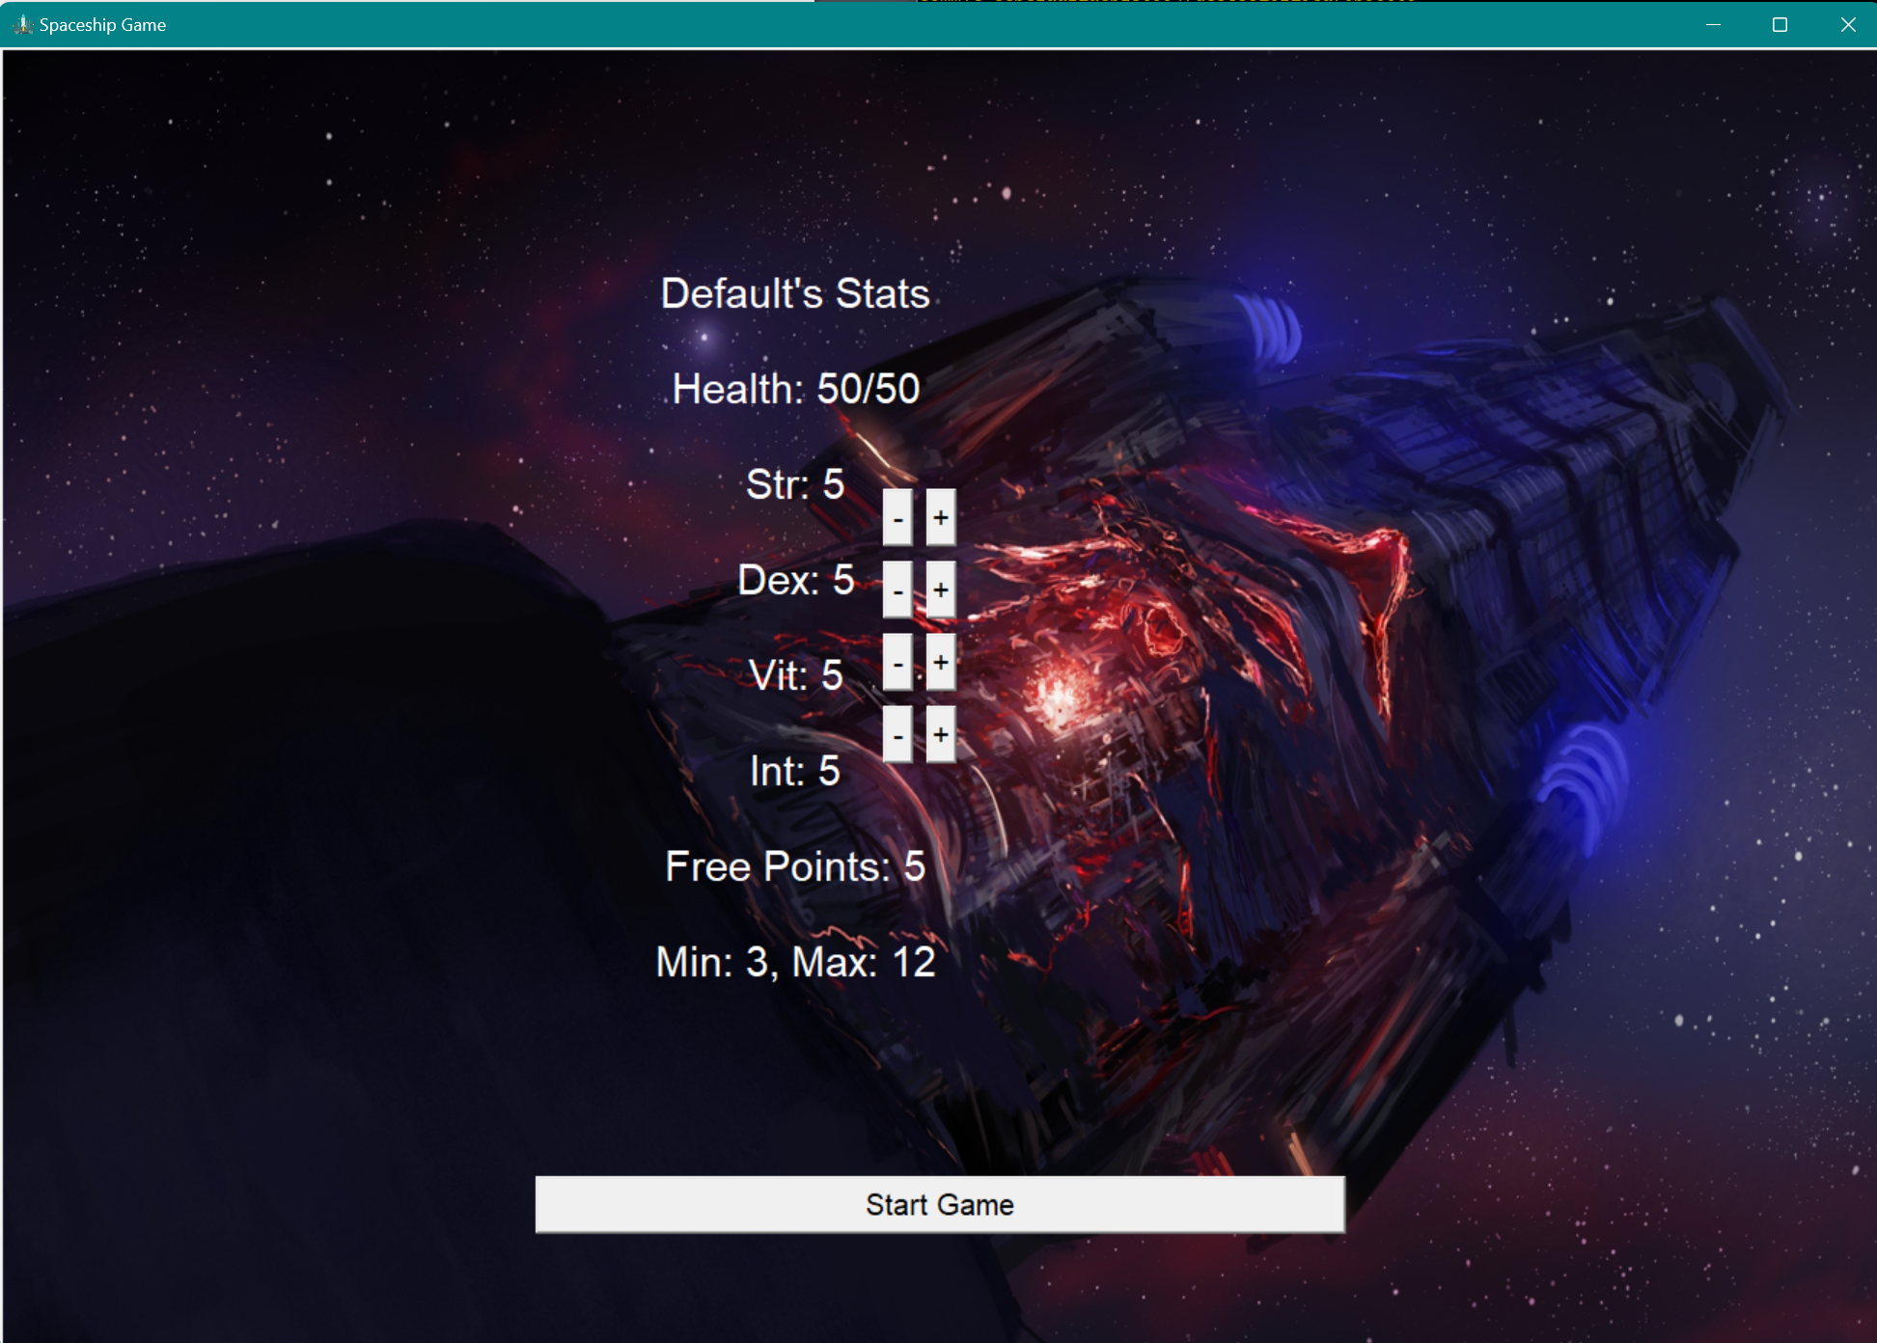Stats display.
* 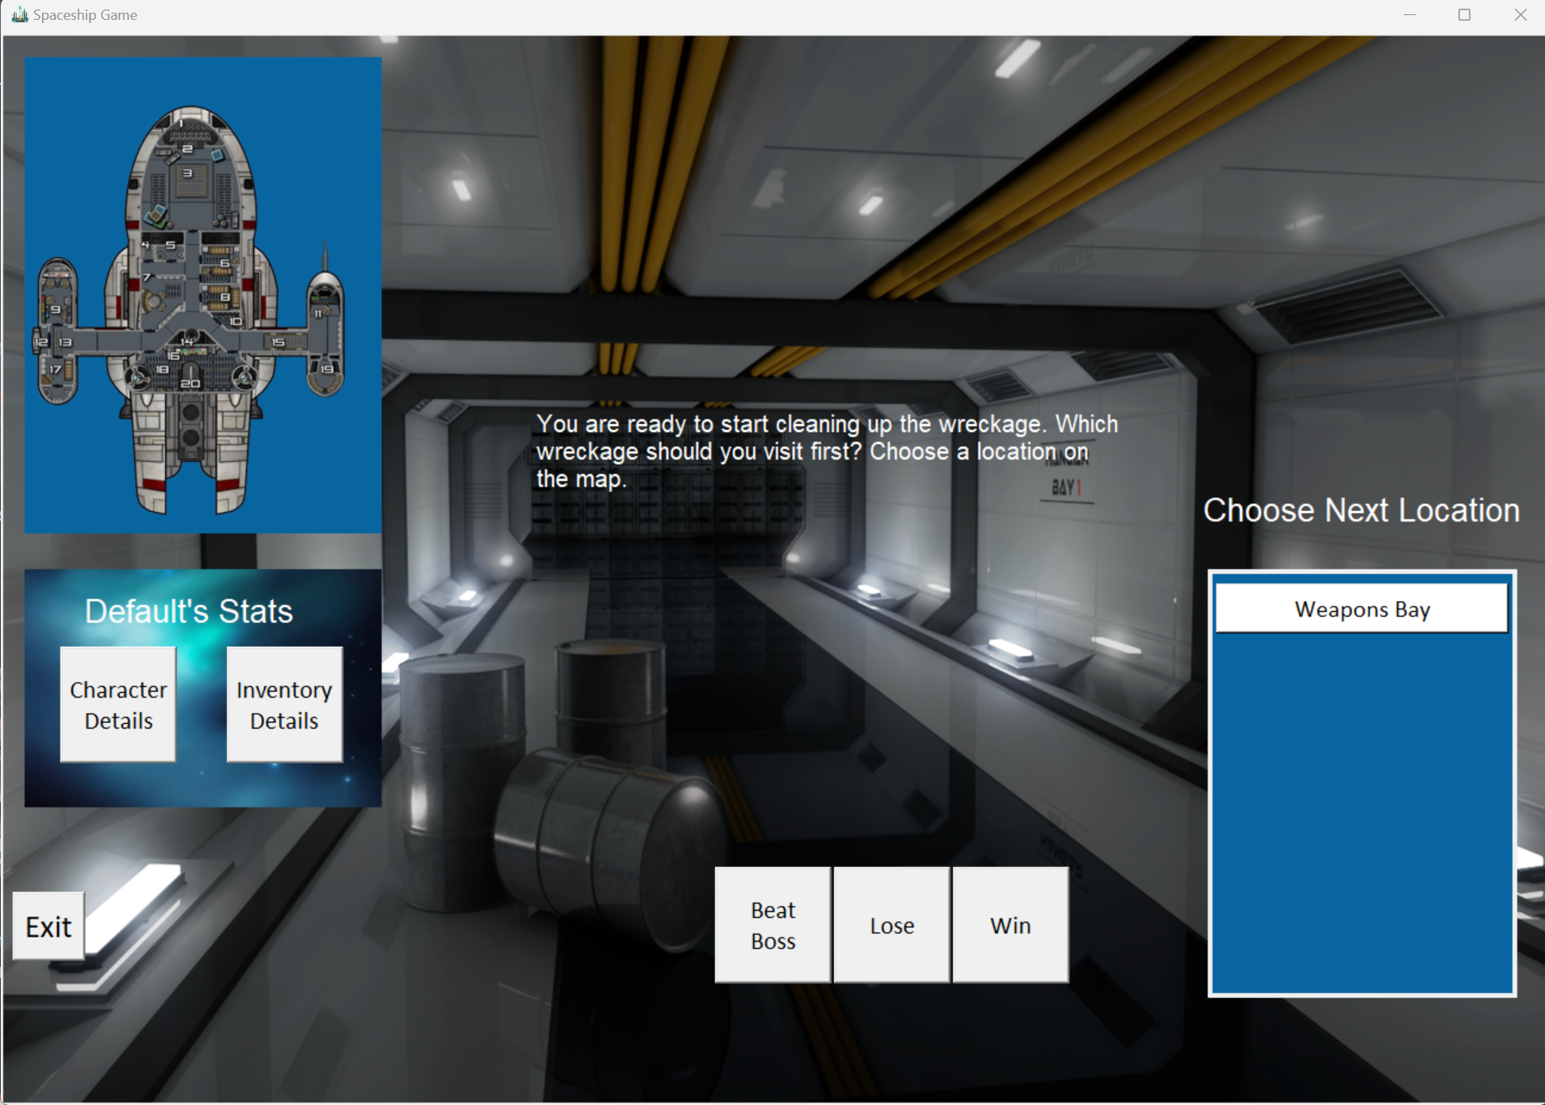Game Screen.
* 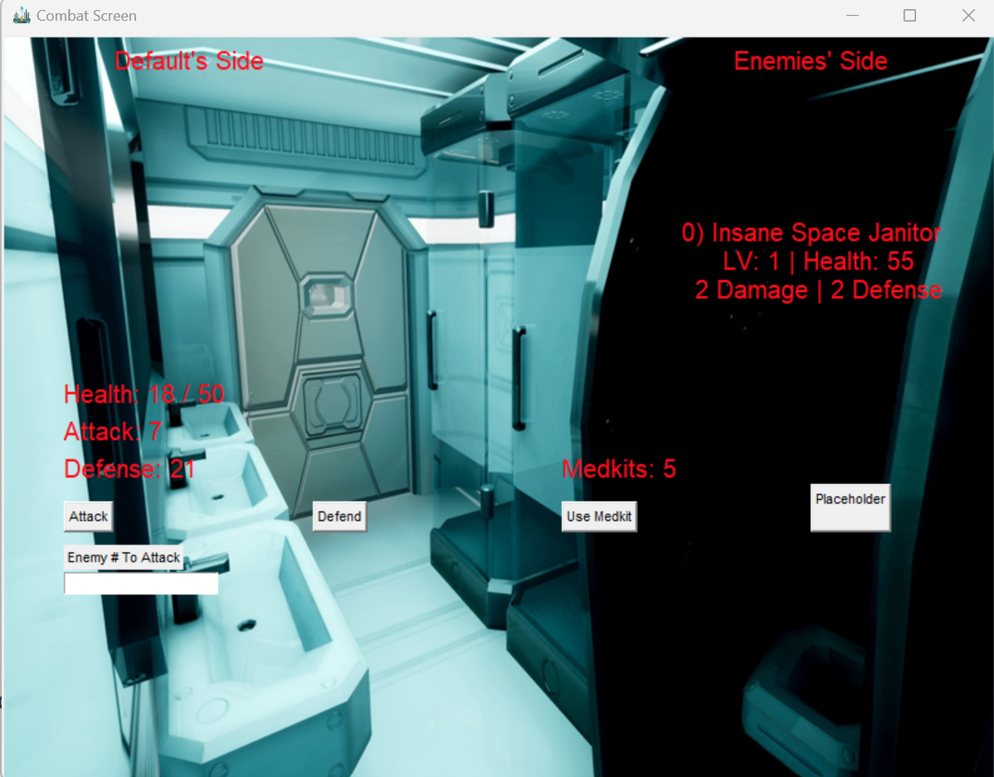Combat Screen (One Room Example)
* 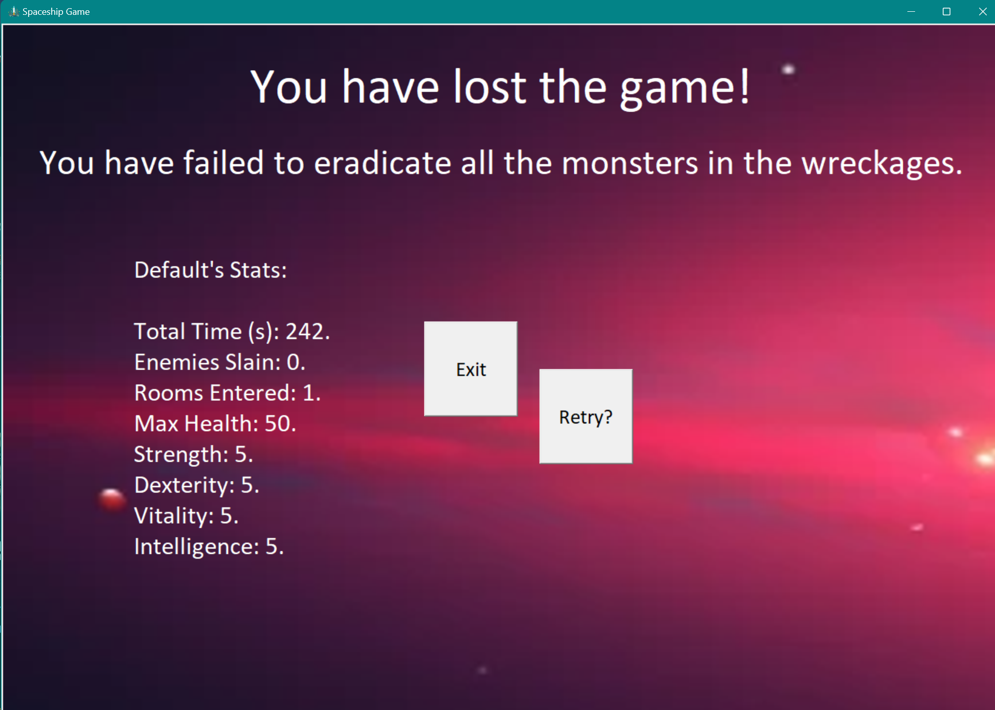Losing the Game.
* 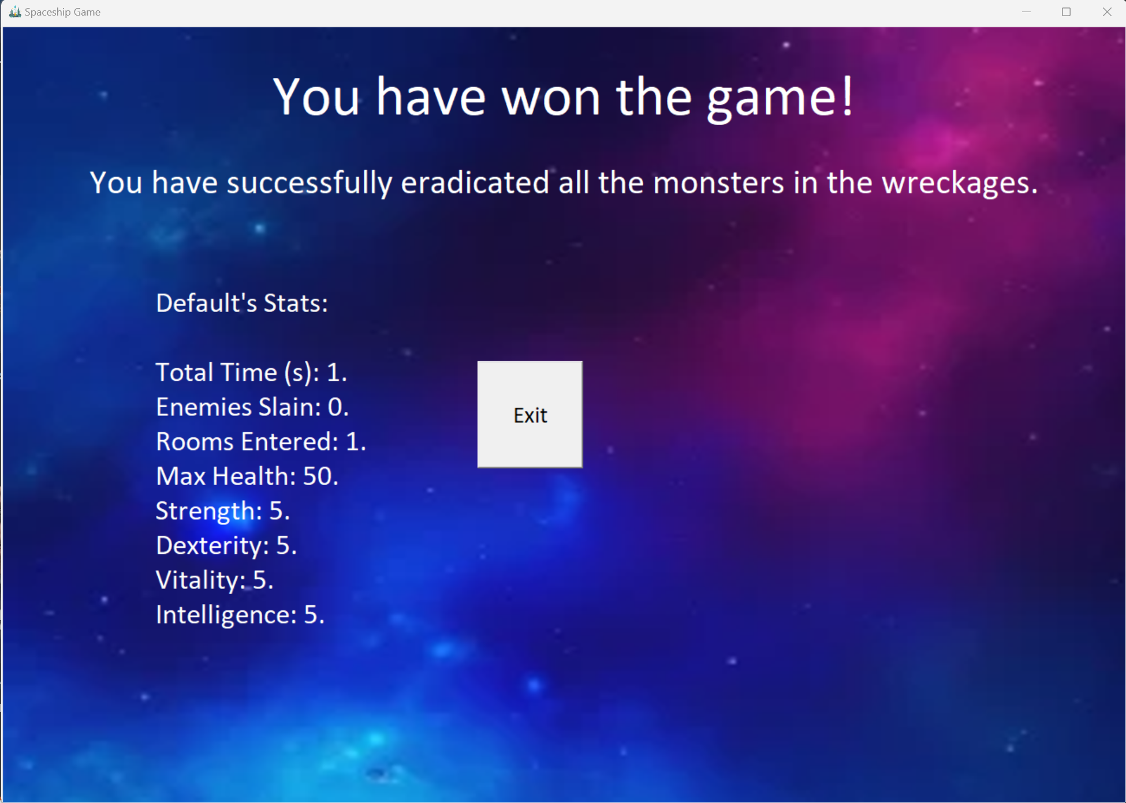Winning The Game
* 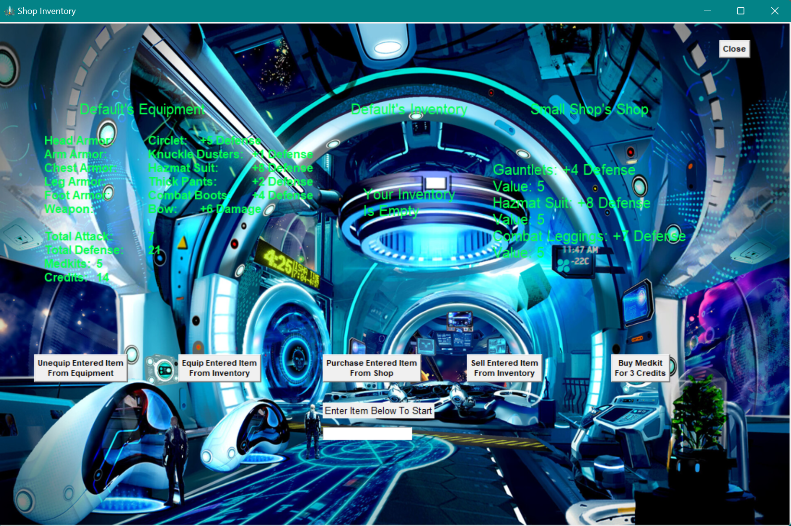Shop Store Screen
* 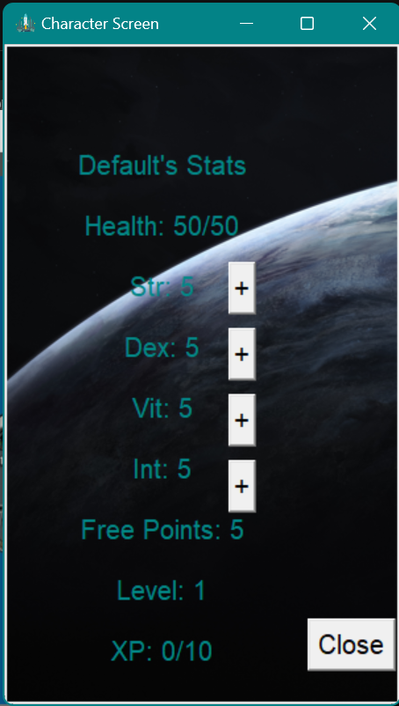Inventory and stats detail.

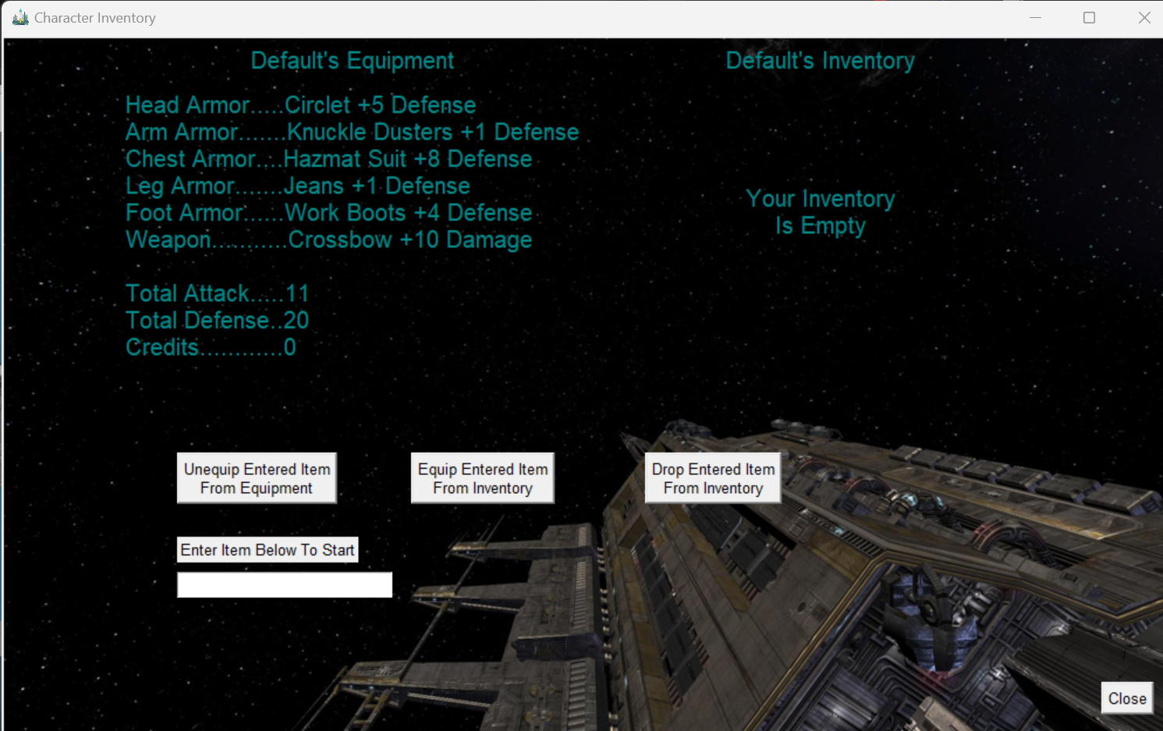

# Project Plan

[Overview of Project Plan, including any customizations to the software process model]

## Requirements & Definition

[Plan for requirements and definition detailed here]

## Development

[Plan for development / implementation detailed here]

## Verification

[Plan for verification detailed here]

## Maintenance

[Plan for maintenance (e.g., problems found by prof or during updates for next release) detailed here]

## Umbrella Activities

Starting the project seemed straightforward because getting the team members to participate in a start-up meeting was relatively easy. However, updating the project with Git was not friendly. To discuss challenges or TODO activities, we met in person and via Zoom meetings, and most of the updates were shared on Discord for detailed information. We hope to continue constant communication for the next release.

# Requirements & Specification

## Use-Cases Diagram

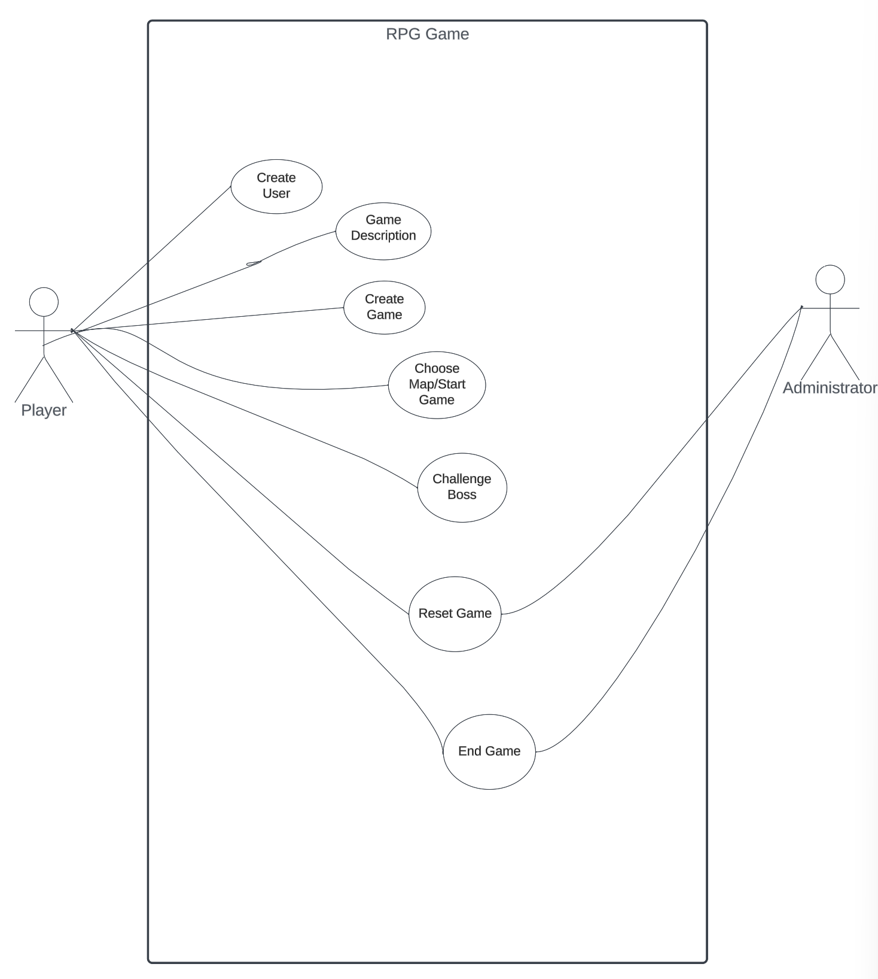

## Use-Cases Diagram Description

|  |  |
| --- | --- |
| Name: | Create User |
| ID | RPG_01 |
| Brief Description. | The user can provide a name, which will appear on the game screen; however, if the user does not feel comfortable giving the name, the game software will default the player’s name to Bob. |
| Actors  Primary/Secondary | Player. |
| Triggers | New user who wants to play the game. There is no save game for now; therefore, returning users will have to start from square one. |
| Precondition | None |
| Primary Flow | 1. Player provides the name. 2. Start options will be displayed on the main screen to continue. 3. Exit button will be available if the player doesn’t want to continue. 4. The player refuses to provide name but want to continue. 5. Repeat option one workflow. 6. The player refuses to provide name and does not want to continue. 7. Exits game. |
| Alternative Flow | None. |
| Minimal Guarantee |  |

|  |  |
| --- | --- |
| Name: | Game Description |
| ID | RPG_02 |
| Brief Description. | The player will be welcomed, and the game description is provided. |
| Actors  Primary/Secondary | Player. |
| Triggers | User must initiate Create User case for this action. |
| Precondition | None. |
| Primary Flow | The user reads instructions and clicks button to continue. |
| Alternative Flow | None. |
| Minimal Guarantee |  |

|  |  |
| --- | --- |
| Name: | Create Game |
| ID | RPG_03 |
| Brief Description. | Players will check the initial stats and how they will be distributed and start the game button to create the game. |
| Actors  Primary/Secondary | Player |
| Triggers | Game Description. |
| Precondition | Players must follow the previous step to create the game. |
| Primary Flow | Because it is the initial phase, the player will receive five free points to play the game, and they don’t have to do anything else but start the game. |
| Alternative Flow | Player can manipulate or rearrange the stats in which the options are the following:   1. Strength 2. Dexterity. 3. Vitality. 4. Intelligence.   By changing the above settings, the player will lose one point for each change. |
| Minimal Guarantee | N/A |

|  |  |
| --- | --- |
| Name: | Choose Map/Start Game |
| ID | RPG_04 |
| Brief Description. | After the game is created, the player will have three paths, each with a map. When a path is chosen, and the player starts selecting the given options, the player will be able to see their location on the map. |
| Actors  Primary/Secondary | Player |
| Triggers | N/A |
| Precondition | Start the Game. |
| Primary Flow | Players will read a message stating which part of the ship they want to explore/clean first. Also, before the player starts the game, they can double-check the stats and readjust them if needed. The inventory option will also be available on the main screen.   1. Entering a room: 2. Nothing happens and can rest after a battle. 3. Chest is found and key is needed to open. If lucky, good items can be found and taken. 4. Villains in the room and player goes into battle mode, or they can run. |
| Alternative Flow | N/A |
| Minimal Guarantee | N/A |

|  |  |
| --- | --- |
| Name: | Challenge Boss |
| ID | RPG_06 |
| Brief Description. | To clear the room or current map, the player must face a stronger opponent(boss); defeating this character will make the player move to the next level. |
| Actors  Primary/Secondary | Player. |
| Triggers | Overcome all challenges that are assigned in each map. |
| Precondition | Chose Map. |
| Primary Flow | After clearing all the previous rooms and arriving at this stage, the player is worn out but collects different items to help them get back in shape(energetic). However, that last room, where the big boss resides, has a different feeling than the previous rooms in which the player realizes he is in trouble. What will he do?   1. **Fight:** The player defends himself and applies skills gained from previous battles. 2. **Run**: the main door is locked upon entrance.    1. Other doors are available but will suck him out of the battleship. |
| Alternative Flow | If the player did not collect boost items and does not have enough to face boos. Reset game for that specific map. |
| Minimal Guarantee | N/A |

|  |  |
| --- | --- |
| Name: | Reset Game |
| ID | RPG_07 |
| Brief Description. | Players did not collect enough items to fight, boss can reset game, or if there is an issue with the software, administrator can rest the game without losing players collected items. |
| Actors  Primary/Secondary | Player  Administrator |
| Triggers | Unable to defeat boss or software issue. |
| Precondition | N/A |
| Primary Flow | 1. Because players must accumulate points and stats to play against the main villain character, they should have what it takes for the battle. However, if the player cannot win, he can reset the game and start again. 2. If the player cannot finish the challenge because of a software issue, the administrator can work on the problem and reset the game without losing the rewards collected if:    1. It is a software issue (bug)    2. A player testing the software. |
| Alternative Flow | N/A |
| Minimal Guarantee | N/A |

|  |  |
| --- | --- |
| Name: | End Game |
| ID | RPG_08 |
| Brief Description. | When opting to end game, player’s window will be terminated and will have to start all over again (for now). |
| Actors  Primary/Secondary | Player  Administrator |
| Triggers | Finish all Leves |
| Precondition | N/A |
| Primary Flow | These options will be available for every player if they want to terminate the game anytime.  Players will be warned that they cannot recover any record if they want to log back in by closing or ending the game.  If it is determined that the player is cheating the system, the game will be terminated as well. |
| Alternative Flow | Reset Game |
| Minimal Guarantee | N/A |

## Natural Language Requirements

[Include requirements here]

## Traceability Matrix

[Include traceability (matrix) from requirements to use cases]

# Design

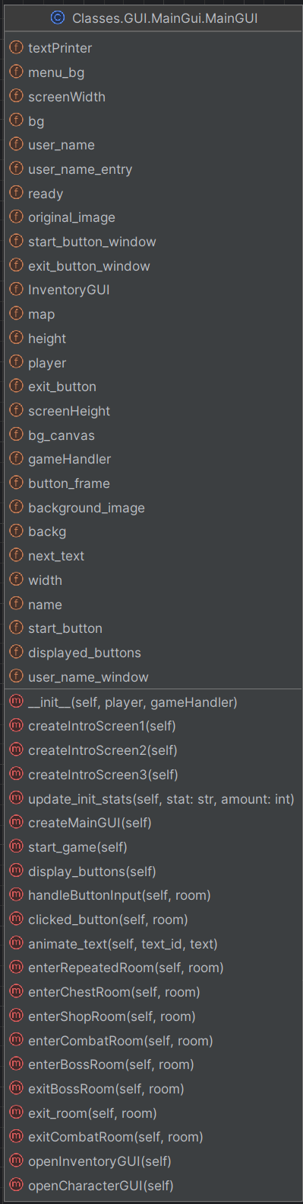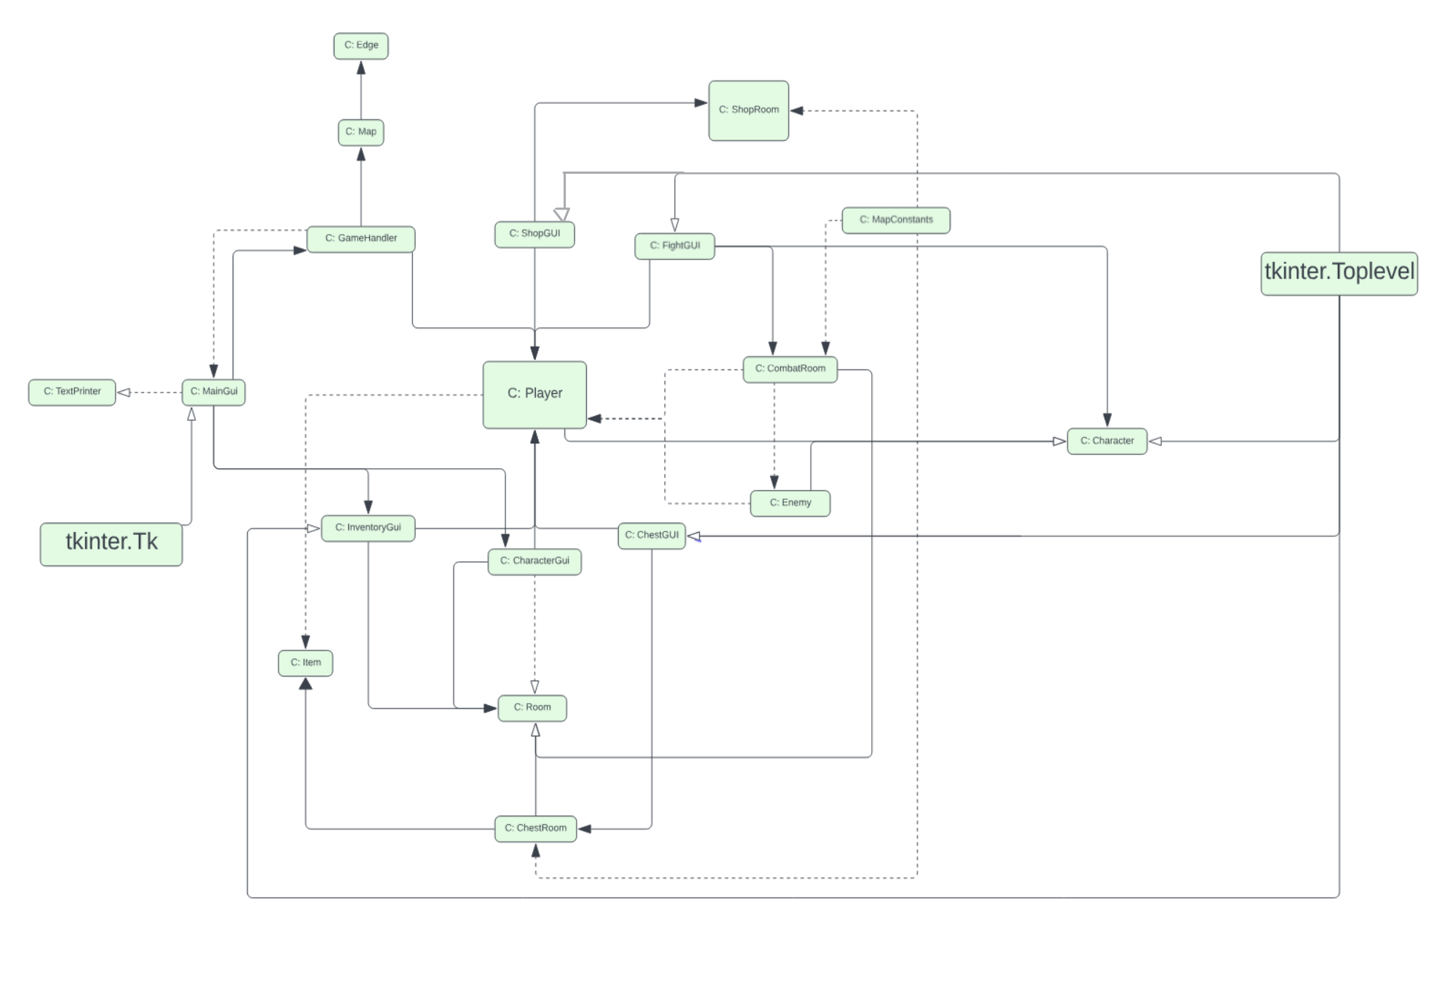The class diagram below was designed using Lucidchart, and because some of the classes contain a lot of instances and methods, we decided to include the Class name only. An example of the MainGui class is shown below the class diagram displaying detailed information.

## Code Standards

[Include report on code standards and justification for any variances]

## Static Analysis

We used the Pylint plugin to analyze and verify the project's compliance; the results of each class are listed below.

Pylint Static Code Analysis

************* Module gamehandler

rpg\Classes\gamehandler.py:66:0: C0303: Trailing whitespace (trailing-whitespace)

rpg\Classes\gamehandler.py:80:0: C0303: Trailing whitespace (trailing-whitespace)

rpg\Classes\gamehandler.py:122:0: C0303: Trailing whitespace (trailing-whitespace)

rpg\Classes\gamehandler.py:123:44: C0303: Trailing whitespace (trailing-whitespace)

rpg\Classes\gamehandler.py:24:8: C0103: Attribute name "GUI" doesn't conform to snake_case naming style (invalid-name)

rpg\Classes\gamehandler.py:25:8: C0103: Attribute name "FightGUI" doesn't conform to snake_case naming style (invalid-name)

rpg\Classes\gamehandler.py:26:8: C0103: Attribute name "ShopGUI" doesn't conform to snake_case naming style (invalid-name)

rpg\Classes\gamehandler.py:27:8: C0103: Attribute name "ChestGUI" doesn't conform to snake_case naming style (invalid-name)

rpg\Classes\gamehandler.py:14:0: R0902: Too many instance attributes (9/7) (too-many-instance-attributes)

rpg\Classes\gamehandler.py:5:0: W0611: Unused import tkinter (unused-import)

************* Module item

rpg\Classes\item.py:75:20: C0303: Trailing whitespace (trailing-whitespace)

rpg\Classes\item.py:19:17: W1514: Using open without explicitly specifying an encoding (unspecified-encoding)

************* Module textprinter

rpg\Classes\textprinter.py:27:0: C0303: Trailing whitespace (trailing-whitespace)

rpg\Classes\textprinter.py:56:0: C0303: Trailing whitespace (trailing-whitespace)

rpg\Classes\textprinter.py:41:8: W0120: Else clause on loop without a break statement, remove the else and de-indent all the code inside it (useless-else-on-loop)

rpg\Classes\textprinter.py:37:26: C3001: Lambda expression assigned to a variable. Define a function using the "def" keyword instead. (unnecessary-lambda-assignment)

************* Module GUI.CharacterGui

rpg\Classes\GUI\CharacterGui.py:1:0: C0103: Module name "CharacterGui" doesn't conform to snake_case naming style (invalid-name)

rpg\Classes\GUI\CharacterGui.py:7:0: W0401: Wildcard import Classes.GUI.MainGui (wildcard-import)

rpg\Classes\GUI\CharacterGui.py:11:0: E0102: class already defined line 7 (function-redefined)

rpg\Classes\GUI\CharacterGui.py:11:0: R0902: Too many instance attributes (10/7) (too-many-instance-attributes)

rpg\Classes\GUI\CharacterGui.py:118:39: W0108: Lambda may not be necessary (unnecessary-lambda)

rpg\Classes\GUI\CharacterGui.py:7:0: W0614: Unused import(s) CharacterGUI, random, ttk, MainGUI, InventoryGUI, FightGUI, ShopGUI and TextPrinter from wildcard import of Classes.GUI.MainGui (unused-wildcard-import)

************* Module GUI.ChestGUI

rpg\Classes\GUI\ChestGUI.py:1:0: C0103: Module name "ChestGUI" doesn't conform to snake_case naming style (invalid-name)

rpg\Classes\GUI\ChestGUI.py:10:0: R0902: Too many instance attributes (12/7) (too-many-instance-attributes)

rpg\Classes\GUI\ChestGUI.py:43:52: W1309: Using an f-string that does not have any interpolated variables (f-string-without-interpolation)

rpg\Classes\GUI\ChestGUI.py:45:49: W0108: Lambda may not be necessary (unnecessary-lambda)

rpg\Classes\GUI\ChestGUI.py:50:53: W1309: Using an f-string that does not have any interpolated variables (f-string-without-interpolation)

rpg\Classes\GUI\ChestGUI.py:54:50: W0108: Lambda may not be necessary (unnecessary-lambda)

************* Module GUI.FightGUI

rpg\Classes\GUI\FightGUI.py:55:0: C0303: Trailing whitespace (trailing-whitespace)

rpg\Classes\GUI\FightGUI.py:244:0: C0303: Trailing whitespace (trailing-whitespace)

rpg\Classes\GUI\FightGUI.py:1:0: C0103: Module name "FightGUI" doesn't conform to snake_case naming style (invalid-name)

rpg\Classes\GUI\FightGUI.py:12:0: R0902: Too many instance attributes (26/7) (too-many-instance-attributes)

rpg\Classes\GUI\FightGUI.py:68:50: W1309: Using an f-string that does not have any interpolated variables (f-string-without-interpolation)

rpg\Classes\GUI\FightGUI.py:70:47: W0108: Lambda may not be necessary (unnecessary-lambda)

rpg\Classes\GUI\FightGUI.py:84:51: W0108: Lambda may not be necessary (unnecessary-lambda)

rpg\Classes\GUI\FightGUI.py:90:74: W0108: Lambda may not be necessary (unnecessary-lambda)

rpg\Classes\GUI\FightGUI.py:8:0: W0611: Unused Room imported from Classes.Rooms.room (unused-import)

************* Module GUI.InventoryGui

rpg\Classes\GUI\InventoryGui.py:1:0: C0103: Module name "InventoryGui" doesn't conform to snake_case naming style (invalid-name)

rpg\Classes\GUI\InventoryGui.py:7:0: W0401: Wildcard import Classes.GUI.MainGui (wildcard-import)

rpg\Classes\GUI\InventoryGui.py:11:0: E0102: class already defined line 7 (function-redefined)

rpg\Classes\GUI\InventoryGui.py:11:0: R0902: Too many instance attributes (21/7) (too-many-instance-attributes)

rpg\Classes\GUI\InventoryGui.py:58:48: W0108: Lambda may not be necessary (unnecessary-lambda)

rpg\Classes\GUI\InventoryGui.py:65:46: W0108: Lambda may not be necessary (unnecessary-lambda)

rpg\Classes\GUI\InventoryGui.py:72:45: W0108: Lambda may not be necessary (unnecessary-lambda)

rpg\Classes\GUI\InventoryGui.py:7:0: W0614: Unused import(s) InventoryGUI, random, ttk, MainGUI, CharacterGUI, FightGUI, ShopGUI and TextPrinter from wildcard import of Classes.GUI.MainGui (unused-wildcard-import)

************* Module GUI.MainGui

rpg\Classes\GUI\MainGui.py:65:0: C0303: Trailing whitespace (trailing-whitespace)

rpg\Classes\GUI\MainGui.py:105:0: C0303: Trailing whitespace (trailing-whitespace)

rpg\Classes\GUI\MainGui.py:188:0: C0303: Trailing whitespace (trailing-whitespace)

rpg\Classes\GUI\MainGui.py:239:0: C0303: Trailing whitespace (trailing-whitespace)

rpg\Classes\GUI\MainGui.py:263:0: C0303: Trailing whitespace (trailing-whitespace)

rpg\Classes\GUI\MainGui.py:282:0: C0303: Trailing whitespace (trailing-whitespace)

rpg\Classes\GUI\MainGui.py:310:0: C0303: Trailing whitespace (trailing-whitespace)

rpg\Classes\GUI\MainGui.py:320:91: C0303: Trailing whitespace (trailing-whitespace)

rpg\Classes\GUI\MainGui.py:325:0: C0303: Trailing whitespace (trailing-whitespace)

rpg\Classes\GUI\MainGui.py:343:0: C0303: Trailing whitespace (trailing-whitespace)

rpg\Classes\GUI\MainGui.py:366:0: C0303: Trailing whitespace (trailing-whitespace)

rpg\Classes\GUI\MainGui.py:374:0: C0303: Trailing whitespace (trailing-whitespace)

rpg\Classes\GUI\MainGui.py:405:0: C0303: Trailing whitespace (trailing-whitespace)

rpg\Classes\GUI\MainGui.py:413:0: C0303: Trailing whitespace (trailing-whitespace)

rpg\Classes\GUI\MainGui.py:456:0: C0303: Trailing whitespace (trailing-whitespace)

rpg\Classes\GUI\MainGui.py:466:0: C0303: Trailing whitespace (trailing-whitespace)

rpg\Classes\GUI\MainGui.py:470:77: C0303: Trailing whitespace (trailing-whitespace)

rpg\Classes\GUI\MainGui.py:480:0: C0303: Trailing whitespace (trailing-whitespace)

rpg\Classes\GUI\MainGui.py:491:0: C0303: Trailing whitespace (trailing-whitespace)

rpg\Classes\GUI\MainGui.py:510:0: C0303: Trailing whitespace (trailing-whitespace)

rpg\Classes\GUI\MainGui.py:519:0: C0303: Trailing whitespace (trailing-whitespace)

rpg\Classes\GUI\MainGui.py:523:77: C0303: Trailing whitespace (trailing-whitespace)

rpg\Classes\GUI\MainGui.py:537:0: C0301: Line too long (102/100) (line-too-long)

rpg\Classes\GUI\MainGui.py:1:0: C0103: Module name "MainGui" doesn't conform to snake_case naming style (invalid-name)

rpg\Classes\GUI\MainGui.py:7:0: W0404: Reimport 'tkinter' (imported line 5) (reimported)

rpg\Classes\GUI\MainGui.py:15:0: W0401: Wildcard import Images (wildcard-import)

rpg\Classes\GUI\MainGui.py:18:0: R0902: Too many instance attributes (26/7) (too-many-instance-attributes)

rpg\Classes\GUI\MainGui.py:253:47: W0108: Lambda may not be necessary (unnecessary-lambda)

rpg\Classes\GUI\MainGui.py:260:46: W0108: Lambda may not be necessary (unnecessary-lambda)

rpg\Classes\GUI\MainGui.py:267:43: W0108: Lambda may not be necessary (unnecessary-lambda)

rpg\Classes\GUI\MainGui.py:311:12: C0103: Variable name "adjacentRoom" doesn't conform to snake_case naming style (invalid-name)

rpg\Classes\GUI\MainGui.py:312:19: C3001: Lambda expression assigned to a variable. Define a function using the "def" keyword instead. (unnecessary-lambda-assignment)

rpg\Classes\GUI\MainGui.py:394:39: W1309: Using an f-string that does not have any interpolated variables (f-string-without-interpolation)

rpg\Classes\GUI\MainGui.py:482:41: W0108: Lambda may not be necessary (unnecessary-lambda)

rpg\Classes\GUI\MainGui.py:18:0: R0904: Too many public methods (22/20) (too-many-public-methods)

rpg\Classes\GUI\MainGui.py:4:0: W0611: Unused import random (unused-import)

rpg\Classes\GUI\MainGui.py:7:0: W0611: Unused tkinter imported as ttk (unused-import)

rpg\Classes\GUI\MainGui.py:11:0: W0611: Unused FightGUI imported from Classes.GUI.FightGUI (unused-import)

rpg\Classes\GUI\MainGui.py:12:0: W0611: Unused ShopGUI imported from Classes.GUI.ShopGUI (unused-import)

rpg\Classes\GUI\MainGui.py:13:0: W0611: Unused Room imported from Classes.Rooms.room (unused-import)

************* Module GUI.ShopGUI

rpg\Classes\GUI\ShopGUI.py:1:0: C0103: Module name "ShopGUI" doesn't conform to snake_case naming style (invalid-name)

rpg\Classes\GUI\ShopGUI.py:10:0: R0902: Too many instance attributes (25/7) (too-many-instance-attributes)

rpg\Classes\GUI\ShopGUI.py:61:48: W0108: Lambda may not be necessary (unnecessary-lambda)

rpg\Classes\GUI\ShopGUI.py:68:46: W0108: Lambda may not be necessary (unnecessary-lambda)

rpg\Classes\GUI\ShopGUI.py:75:49: W0108: Lambda may not be necessary (unnecessary-lambda)

rpg\Classes\GUI\ShopGUI.py:82:45: W0108: Lambda may not be necessary (unnecessary-lambda)

rpg\Classes\GUI\ShopGUI.py:89:51: W0108: Lambda may not be necessary (unnecessary-lambda)

************* Module map

rpg\Classes\Map\map.py:42:0: C0303: Trailing whitespace (trailing-whitespace)

rpg\Classes\Map\map.py:110:0: C0303: Trailing whitespace (trailing-whitespace)

rpg\Classes\Map\map.py:132:0: C0303: Trailing whitespace (trailing-whitespace)

rpg\Classes\Map\map.py:67:17: W0511: TODO: delete later (fixme)

rpg\Classes\Map\map.py:57:8: C0206: Consider iterating with .items() (consider-using-dict-items)

rpg\Classes\Map\map.py:4:0: W0611: Unused import math (unused-import)

************* Module mapconstants

rpg\Classes\Map\mapconstants.py:11:0: R0903: Too few public methods (0/2) (too-few-public-methods)

rpg\Classes\Map\mapconstants.py:8:0: W0611: Unused StartRoom imported from Classes.Rooms.start_room (unused-import)

************* Module Rooms.boss_room

rpg\Classes\Rooms\boss_room.py:21:0: C0303: Trailing whitespace (trailing-whitespace)

rpg\Classes\Rooms\boss_room.py:4:0: W0611: Unused CombatRoom imported from Classes.Rooms.combat_room (unused-import)

************* Module Rooms.combat_room

rpg\Classes\Rooms\combat_room.py:10:0: R0902: Too many instance attributes (8/7) (too-many-instance-attributes)

rpg\Classes\Rooms\combat_room.py:23:17: W1514: Using open without explicitly specifying an encoding (unspecified-encoding)

rpg\Classes\Rooms\combat_room.py:56:26: E1101: Instance of 'tuple' has no 'stats' member (no-member)

rpg\Classes\Rooms\combat_room.py:57:12: W0612: Unused variable 'i' (unused-variable)

rpg\Classes\Rooms\combat_room.py:67:39: E1101: Instance of 'tuple' has no 'stats' member (no-member)

rpg\Classes\Rooms\combat_room.py:68:46: E1101: Instance of 'tuple' has no 'stats' member (no-member)

************* Module Rooms.room

rpg\Classes\Rooms\room.py:54:0: C0303: Trailing whitespace (trailing-whitespace)

rpg\Classes\Rooms\room.py:85:0: C0303: Trailing whitespace (trailing-whitespace)

rpg\Classes\Rooms\room.py:100:0: C0303: Trailing whitespace (trailing-whitespace)

rpg\Classes\Rooms\room.py:107:0: C0303: Trailing whitespace (trailing-whitespace)

rpg\Classes\Rooms\room.py:8:0: R0902: Too many instance attributes (9/7) (too-many-instance-attributes)

rpg\Classes\Rooms\room.py:94:13: W1514: Using open without explicitly specifying an encoding (unspecified-encoding)

rpg\Classes\Rooms\room.py:98:20: E1120: No value for argument 'seq' in method call (no-value-for-parameter)

************* Module Rooms.shop_room

rpg\Classes\Rooms\shop_room.py:20:12: W0612: Unused variable 'i' (unused-variable)

************* Module Tests.edge_tests

rpg\Tests\edge_tests.py:39:12: C2801: Unnecessarily calls dunder method __repr__. Use repr built-in function. (unnecessary-dunder-call)

************* Module Tests.item_tests

rpg\Tests\item_tests.py:16:8: W4902: Using deprecated method assertNotEquals() (deprecated-method)

************* Module Tests.room_tests

rpg\Tests\room_tests.py:114:25: C2801: Unnecessarily calls dunder method __repr__. Use repr built-in function. (unnecessary-dunder-call)

rpg\Tests\room_tests.py:121:24: C2801: Unnecessarily calls dunder method __eq__. Use == operator. (unnecessary-dunder-call)

rpg\Tests\room_tests.py:123:25: C2801: Unnecessarily calls dunder method __eq__. Use == operator. (unnecessary-dunder-call)

************* Module Tests.start_room_tests

rpg\Tests\start_room_tests.py:1:0: R0801: Similar lines in 2 files

==GUI.CharacterGui:[23:35]

==GUI.InventoryGui:[23:33]

self.width = self.winfo_width()

self.height = self.winfo_height()

self.minsize(self.width, self.height) # Minimum size of the window, can be maximized.

self.iconbitmap('Images/SpaceShip.ico')

self.width = self.winfo_width()

self.height = self.winfo_height()

self.player = player

self.room = room

self.gui = gui

# Customize screen (duplicate-code)

rpg\Tests\start_room_tests.py:1:0: R0801: Similar lines in 2 files

==GUI.InventoryGui:[174:182]

==GUI.ShopGUI:[199:207]

self.read_entry_box()

if self.read_entry_box() is not None:

item_to_remove = self.item_entry

for item in self.player.equipment.values():

if item.stats["name"] == item_to_remove:

self.player.unequip_item(item)

self.player.update_defense()

self.player.update_attack() (duplicate-code)

rpg\Tests\start_room_tests.py:1:0: R0801: Similar lines in 2 files

==GUI.InventoryGui:[160:168]

==GUI.ShopGUI:[186:194]

self.read_entry_box()

if self.read_entry_box() is not None:

item_to_equip = self.item_entry

for item in self.player.inventory:

if item.stats["name"] == item_to_equip:

self.player.equip_item(item)

self.player.update_defense()

self.player.update_attack() (duplicate-code)

rpg\Tests\start_room_tests.py:1:0: R0801: Similar lines in 2 files

==GUI.FightGUI:[24:33]

==GUI.InventoryGui:[23:32]

self.width = self.winfo_width()

self.height = self.winfo_height()

self.minsize(self.width, self.height) # Minimum size of the window, can be maximized.

self.iconbitmap('Images/SpaceShip.ico')

self.width = self.winfo_width()

self.height = self.winfo_height()

self.player = player

self.room = room (duplicate-code)

rpg\Tests\start_room_tests.py:1:0: R0801: Similar lines in 2 files

==GUI.CharacterGui:[84:92]

==GUI.MainGui:[142:150]

text=self.player.name + "'s Stats" +

"\n\nHealth: " + str(self.player.stats["Health"]) +

"/" + str(self.player.stats["Max Health"]) +

"\n\nStr: " + str(self.player.stats["Strength"]) +

"\n\nDex: " + str(self.player.stats["Dexterity"]) +

"\n\nVit: " + str(self.player.stats["Vitality"]) +

"\n\nInt: " + str(self.player.stats["Intelligence"]) +

"\n\nFree Points: " + str(self.player.stats["Stat Points"]) + (duplicate-code)

rpg\Tests\start_room_tests.py:1:0: R0801: Similar lines in 2 files

==GUI.CharacterGui:[23:32]

==GUI.ChestGUI:[22:32]

self.width = self.winfo_width()

self.height = self.winfo_height()

self.minsize(self.width, self.height) # Minimum size of the window, can be maximized.

self.iconbitmap('Images/SpaceShip.ico')

self.width = self.winfo_width()

self.height = self.winfo_height()

self.player = player

self.room = room

(duplicate-code)

rpg\Tests\start_room_tests.py:1:0: R0801: Similar lines in 2 files

==GUI.CharacterGui:[23:31]

==GUI.ShopGUI:[22:30]

self.width = self.winfo_width()

self.height = self.winfo_height()

self.minsize(self.width, self.height) # Minimum size of the window, can be maximized.

self.iconbitmap('Images/SpaceShip.ico')

self.width = self.winfo_width()

self.height = self.winfo_height()

self.player = player (duplicate-code)

rpg\Tests\start_room_tests.py:1:0: R0801: Similar lines in 2 files

==GUI.InventoryGui:[121:126]

==GUI.ShopGUI:[139:144]

self.bg_canvas.delete("inventory")

self.inventory_text = ""

if len(self.player.inventory) > 0:

for item in self.player.inventory:

if item.stats["type"] == "Weapon": (duplicate-code)

------------------------------------------------------------------

Your code has been rated at 9.13/10 (previous run: 8.88/10, +0.25)

## Code Documentation

File Link to Full HTML - [..\html\rpg\index.html](../html/rpg/index.html)

Image Example of HTML Documentation

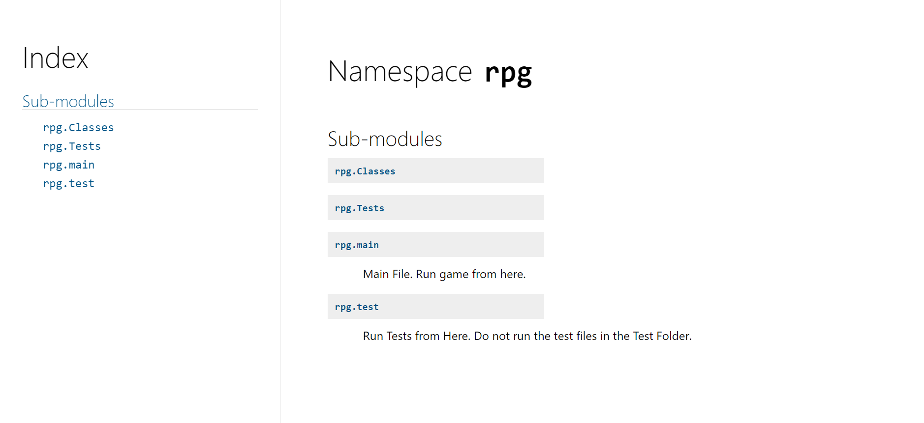

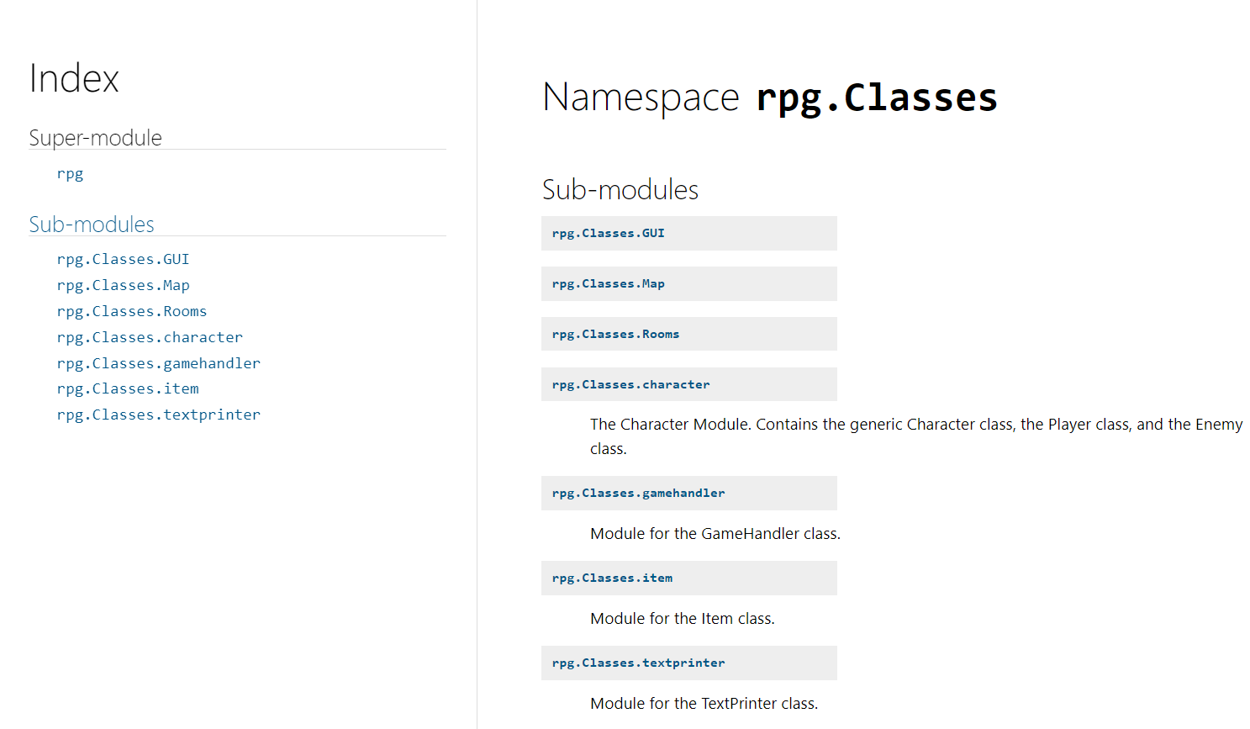

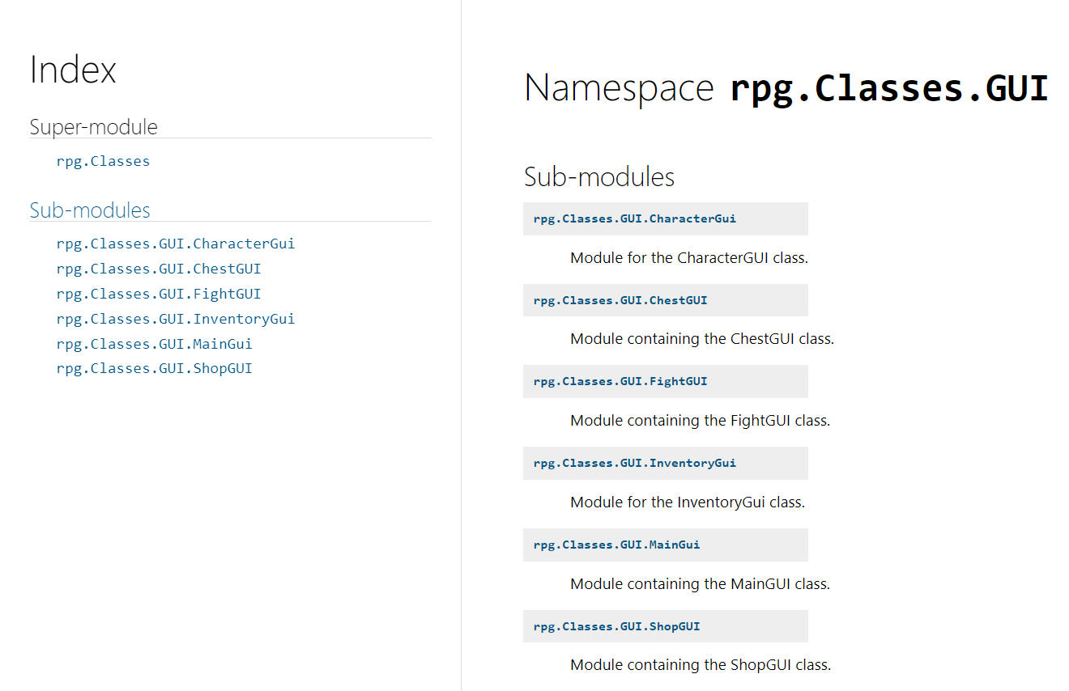

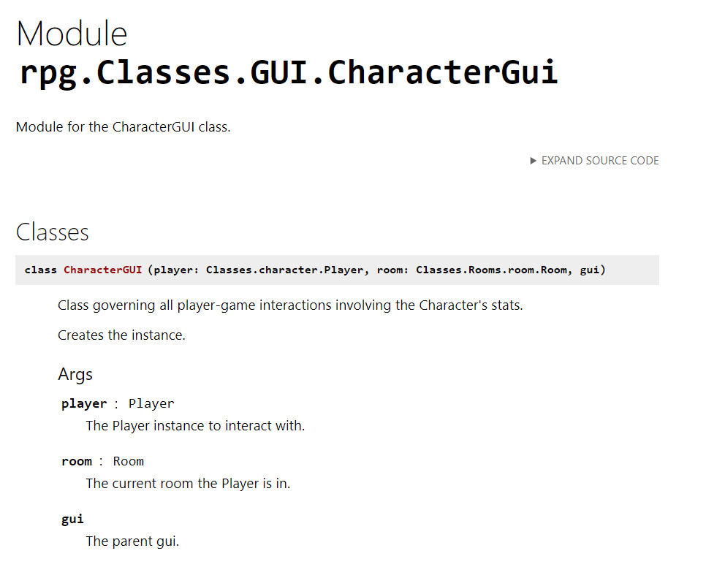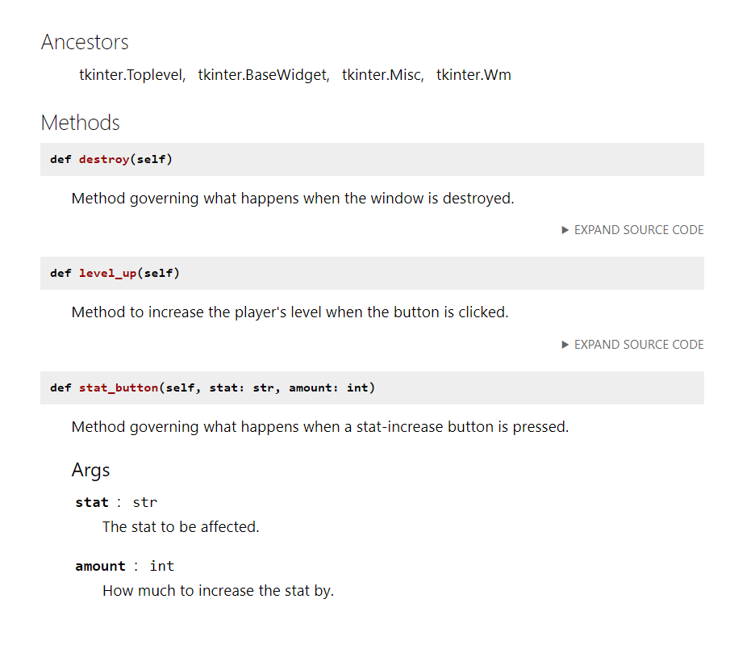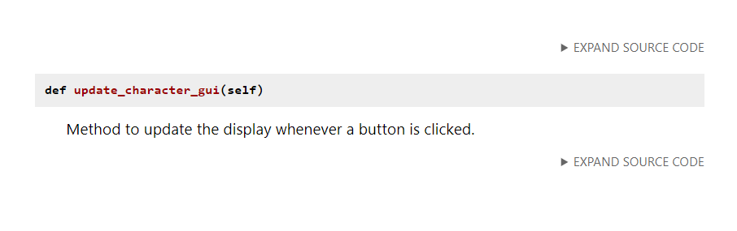

## Configuration Management

Since we were using git/GitHub to track our project, each group member worked on developing the game software and pushed it into the remote repository when possible. Although we did not have a team lead, Eric would briefly describe what needed to be done so we could work on it when possible.

When committing the changes, we started with a brief description of each group member's changes. However, it took effort to follow sometimes, and we discussed that a detailed description would help us understand the changes better.

Although we did not write detailed information when committing, we used Discord constantly to describe what was done after pushing the changes to the GitHub repository; thus, it helped us better track the changes.

The URL address for the project is listed below.

<https://github.com/Evickerest/rpg.git>

# Verification

## Unit Tests

Unit Tests Done Using Python’s unittest module.

## Code Coverage

Automated unittest Coverage Report

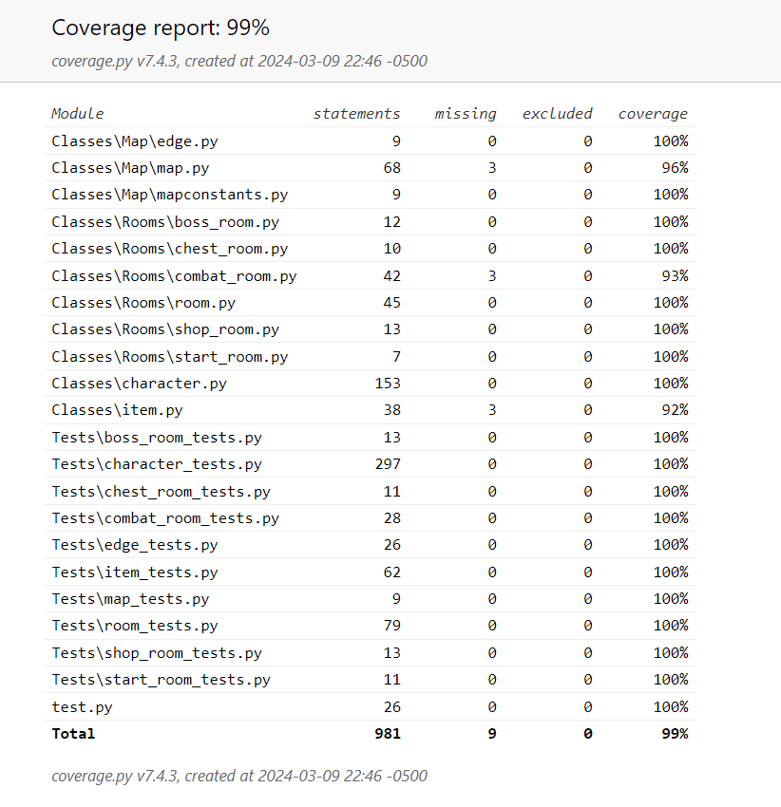

Missing FightGUI, ShopGUI, ChestGUI, MainGui, InventoryGui, CharacterGui, and gamehandler files. (None were tested using automated unittesting).

FightGUI.py

* Manual testing was performed.
  + General Testing
    - Can’t leave until all enemies are killed.
    - Can’t open another window while a FightGUI window is still active.
    - Player and enemy information are correctly displayed and updated.
  + Enemy Targeting Entry Box
    - Retains previously attacked enemy
      * Clears itself after an enemy is killed
  + Attack Button
    - Does nothing if no enemy or invalid enemy is targeted (Invalid integer target, attempted to target enemy name, left targeting box empty, etc.).
  + Defend Button
    - Correctly increases player’s defense by 50% for 1 turn before reducing it back to normal.
  + Use Medkit Button
    - Correctly heals the player and uses a medkit.
    - Heals nothing if no medkits are left but still acts as a full turn.
  + Placeholder Button
    - Can be pressed but nothing will happen.
  + Enemy Killed
    - Player gains XP and Credits (currency) upon killing an enemy.
    - Enemy is correctly removed from the list of active combatants.
  + Player Killed
    - Destroys the window and prompts the end game method.
  + Exit Button
    - Available once all enemies are killed,
    - Deletes all buttons except for the use medkit button.
    - Cannot leave unless all enemies are killed.

ChestGUI.py

* Manual testing was performed.
  + General Testing
    - Can leave at any time.
    - Can’t open another window while a ChestGUI window is still active.
    - Item information is correctly displayed and updated.
      * What item can be looted.
      * How much it’s worth in Credits.
  + Loot Button
    - Correctly adds the item to your inventory.
    - Updates player inventory (backend).
    - Correctly closes window and runs exit_room method.
  + Scrap Button
    - Correctly removes the item from the room and adds its Credit value to the player.
    - Correctly closes window and runs exit_room method.

ShopGUI.py

* Manual testing was performed.
  + General Testing
    - Can leave at any time.
    - Can’t open another window while a ShopGUI window is still active.
    - Player and shop information are correctly displayed and updated.
  + Item Targeting Entry Box
    - Correctly allows you to select the various items.
    - Retains previously selected item.
  + Unequip Button
    - Correctly unequips the targeted item from your equipment and adds it to your inventory.
      * Replaces said equipment slot with a placeholder item.
    - Updates player information.
  + Equip Button
    - Correctly equips the targeted item from your inventory.
      * Swaps out equipment if necessary.
        + Adds previously worn equipment to inventory.
      * Updates player information.
  + Purchase Button
    - Buys item from shop.
      * Correctly adds it to the player’s inventory, removes it from the shop’s, and deducts player’s credits.
  + Sell Button
    - Sells item from inventory.
      * Correctly adds it to the shop’s inventory, removes it from the player’s, and adds player’s credits.
  + Buy Medkit Button
    - Buy medkits in exchange for Credits.
      * Confirmed that you can only buy if the player has enough credits.
    - Correctly updates player information.
  + Close Button
    - Available always.
    - Destroys the window.

InventoryGUI.py

* Manual testing was performed.
  + General Testing
    - Can leave at any time.
    - Can’t open another window while an InventroyGUI window is still active.
    - Player information is correctly displayed and updated.
      * Equipment
      * Inventory
      * Total stats
  + Item Targeting Entry Box
    - Correctly allows you to select the various items.
    - Retains previously selected item.
  + Unequip Button
    - Correctly unequips the targeted item from your equipment and adds it to your inventory.
      * Replaces said equipment slot with a placeholder item.
    - Updates player information.
  + Equip Button
    - Correctly equips the targeted item from your inventory.
      * Swaps out equipment if necessary.
        + Adds previously worn equipment to inventory.
      * Updates player information.
  + Drop Button
    - Correctly removes an item from the player’s inventory.
      * Fully deletes item, no way of regaining it.
  + Close Button
    - Available always.
    - Destroys the window.

CharacterGui.py

* Manual testing was performed.
  + General Testing
    - Can’t open window if another window is already present.
    - Can’t open another window until this window is destroyed.
  + LV UP Button
    - Checked that the lv-up button displays only if the player has enough XP to level up.
    - Also checked that the button disappears after a level up if the player no longer has enough XP to level up.
    - Lv-up also correctly adds 5 stat points.
  + Add Stat Points Buttons
    - Checked that the add stat points buttons work.
    - Also checked that the buttons only show if the play has unassigned stat points.
    - Also confirmed that leveling up with 0 stat points (and thus no + buttons) will create new + buttons.
  + Close Button
    - Works correctly and destroys the window.

MainGui.py and gamehandler.py

* Manual testing was performed via playing the game.
  + Main Menu
    - Exit Button works.
    - Start Button works.
    - Username entry box works.
      * If left empty, it sues the default player name instead.
  + Game Intro Screen
    - Displays the correct information.
      * Updates player name when necessary.
    - Click to Continue Button works correctly.
  + Character Creation Screen
    - Displays and updates player information.
    - Stat Increase and Decrease Buttons work correctly.
      * Prevents stats from going under 3 or over 12.
      * Player Max Health and current Health updates correctly when Vitality changes.
  + Game Over
    - Correctly displays information about your run (Time, Enemies Killed, Rooms Entered, Player Stats).
    - Correctly tells if you beat the boss (Victory)
      * Offers an exit button that works.
    - Correctly tells if you died (Loss)
      * Offers a retry with a new game button (Currently nonfunctional)
        + No buttons work in the new game.

## Requirements Coverage

[Include traceability (matrix) from requirements to test procedures]

# Postmortem

Phuc Le

* Role – Product Dev. Team
* Specific Work
  + Unit Testing (With unittest module)
  + Source Code Documentation
  + Static Code Analysis (Pylint)
  + GUI Implementation (Fight-, Chest-, Shop-, Character-, Inventory- GUIs, worked on player-system interactions except for graphics)
    - Character Creation as well
  + Implementation of the Character, Player, Enemy, and Item classes
* Self Reflection
  + Git was a lot more annoying than I expected. Merge conflicts were insanely difficult to resolve in PyCharm for some reason.
  + I was definitely very scattered in terms of what work I did and didn’t do so good at keeping the team up to date on what I was changing.

Adrian Perez:

* Gui dev. Team
* Documentation
* Design.

Reflection:

My lack of coding skills has put me in a very uncomfortable position because not contributing as much as my other team members is unfair. However, I try my very best to assist when I can, and of course, Git is not helping at all. I cannot say it all the time, but it has happened that I had to delete the entire project and clone it again because I cannot push and pull my work to or from GitHub.

The other two members have helped assist me when they can; thus, I will continue to work hard for the next phase.

## Earned Value

[Include the earned value calculations for your current status and any explanation of over/under runs]

## Variances

[Include any additional variance (time, coverage, functionality, …) explanations necessary]

## Lessons Learned

[Include lessons learned]

# Work Cited

*Artworks by Artists from around the World | Artstation*, www.artstation.com/marketplace/game-dev/artworks. Accessed 7 Mar. 2024.

Creative, Make It. “Lights and Shadows: Sci-Fi Lift: After Effects.” *Behance*, 1999, www.behance.net/gallery/44429607/Lights-and-Shadows-Sci-fi-lift-After-Effects.

“Inside a Sci-Fi Spaceship Escape Pod That Is a Mind: Stable Diffusion.” *OpenArt*, openart.ai/discovery/sd-1006280114948030534. Accessed 9 Mar. 2024.

“Lifegoods.Com.” *MY*, my-lifegoods.com/. Accessed 9 Mar. 2024.

Santamarian, Ioana. *Retro Sci-Fi Kitchen, Ioana Santamarian*, 2019, www.artstation.com/artwork/2xZYWJ.

“Sci Fi Space Station Interior in Environments - UE Marketplace.” *Unreal Engine*, 1999, www.unrealengine.com/marketplace/en-US/product/sci-fi-space-station-interior.

*Sci-Fi Hangar Concept, Daniel Jakobi*, www.artstation.com/artwork/klgkbx. Accessed 7 Mar. 2024.

“The SHIPMAS Season Approaches: Countdown to 9 New Star Atlas Spaceships.” *Medium*, Star Atlas, 10 Dec. 2021, medium.com/star-atlas/shipmas-9-new-star-atlas-spaceships-f24afc7956b1.

“Spaceship Cabin.” *Cool Ideas in Photos*, en.idei.club/8121-spaceship-cabin.html. Accessed 1 Mar. 2024.

“Spaceship Hallway C4d 1920x1080 by Xcustomgraphix on DeviantArt.” *By xCustomGraphix on DeviantArt*, www.deviantart.com/xcustomgraphix/art/Spaceship-hallway-C4D-1920x1080-407417487. Accessed 7 Mar. 2024.

*Wallpaper Abyss - HD Wallpapers, Background Images*, wall.alphacoders.com/. Accessed 9 Mar. 2024.